Problem Statement 3: Load data from Azure Blob storage to a database in Azure SQL Database by using Azure Data Factory.

* No need to create another data factory as I have one already.
* I created a source blob and uploaded the emp.txt file to the input folder I created.
* I created a sink SQL table. I used the SQL script to create the dbo.emp table in my database.
* I created the pipeline in this data factory with a copy activity that copies data from Azure Blob storage to a database in Azure SQL Database. The configuration involves copying from a file-based data store to a relational data store
* I then validated, debugged and published my pipeline.
* I monitored the pipeline and kept refreshing till they all succeeded.
* I triggered the pipeline manually and then also set the trigger on a schedule to run every minute.
* I always make sure I stopped the triggers to avoid incurring more cost.

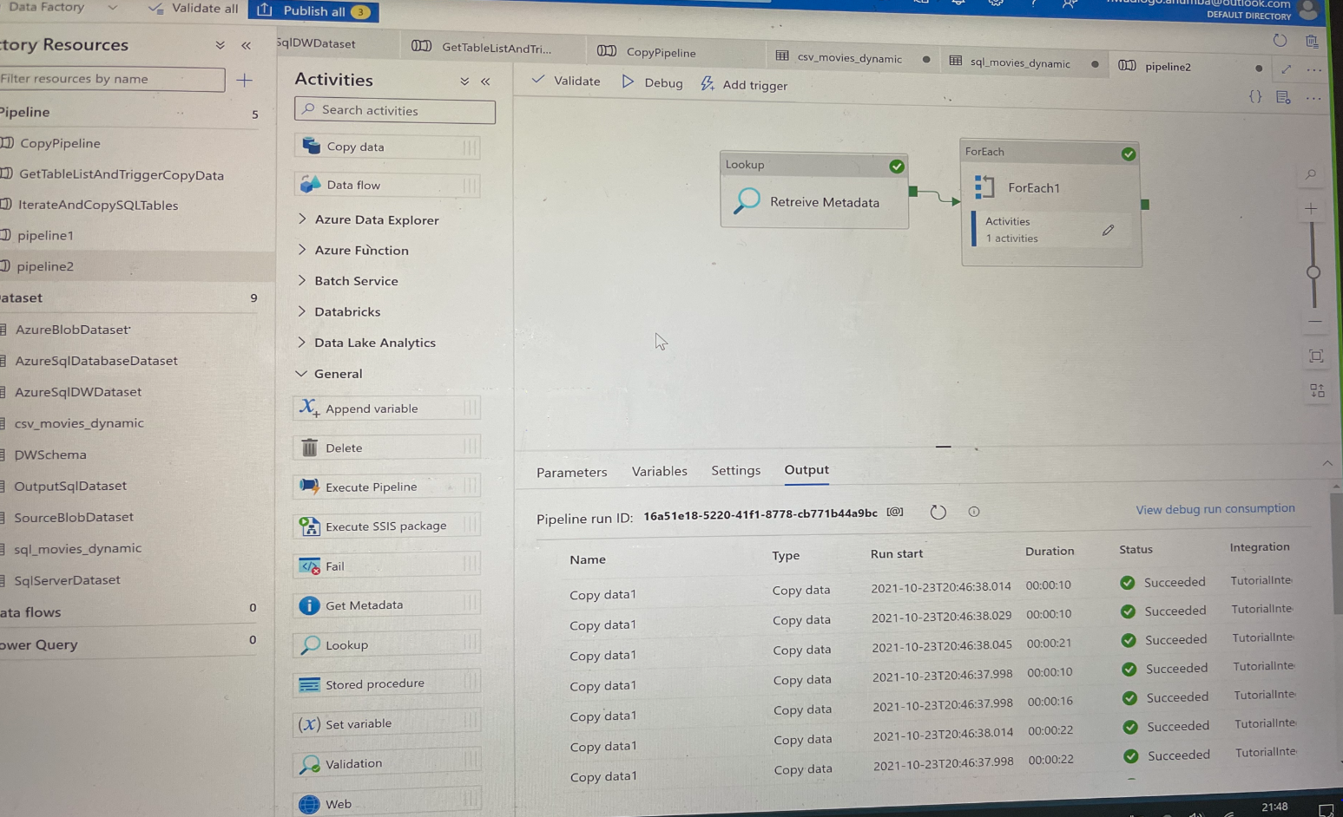

Figure 1: Succeeded pipeline runs